A

Mini Project Report

On

**“Project Management app”**

**Bachelor of Technology**

In

**COMPUTER SCIENCE AND ENGINEERING (CSE/IOT)**

**By**

**PRAKHAR SAHU**

**RACHANA SAHU**

** DEPARTMENT OF COMPUTER SCIENCE AND ENGINEERING**

**SHRI SHANKARACHARYA TECHNICAL CAMPUS,**

**JUNWANI, BHILAI(C.G.)**

**SESSION 2022-2023**

**CERTIFICATE**

This is to certify that the thesis report of the project submitted is an outcome of the project entitled **“MINI PROJECT”** carried out by **PRAKHAR SAHU, RACHANA SAHU** bearing Roll no**. 301411120045, 3036111200001** carried out under my guidance and supervision for the award of Degree in B.Tech in **Computer Science and Engineering** of Shri Shankaracharya Technical Campus, Bhilai (C.G.), India.

To the best of my knowledge the report.

(1) Embodies the work of the candidates herself/himself.

(2) Fulfills the requirements of the ordinance relating to the B.Tech Degree of the University. And,

(3) Is up to the desired standard for the purpose of which is submitted.

**Prof. Sampada V Massey**

Computer Science & Engineering Department

**Shri Shankaracharya Technical Campus**

**Junwani, Bhilai(C.G.)**

**(Signature of Head of Department with seal)**

**ACKNOWLEDGEMENT**

As the professional courses do not only require the theoretical knowledge but need to cover practical aspect too. Universities have started conducting training programs for students. So, that they get simple view of practical knowledge.

No work of significance can be claimed on a result of an individual Efforts and same holds true further for this project as well, for through it carries my name the energy of many have contributed in no small measure in completion of this project.

I am very thankful our teacher “Sampada V. Massey” Mam who guided me throughout this project this project.

(Signature of student)

**Abstract**

In this project we are going to build a web app/website that allow users store their project data (like GitHub link, image, technology used) and group of tasks that is performed or taken by user to create the project. We used to design the app simple and user-friendly so that anyone can use it without any problem. Sometime app with more functionality but complex/difficult design make user to not to use this app so, User Interface and Experience plays an important role as its functionality. Our app provides an API to every user who registered to our app, and make their project available to them. They can integrate their data to other applications such as Porfilio website. As you progress in your project you can track or record as timeline to your project that help to check the consistency and no. of working days to complete the project and use it to check how much you are giving to your work. We are using API – Application Programming Interface used is a way for two or more computer programs to communicate with each other. It is type of software, offering a service to other pieces of software.

**Table of contents**

* Introduction
* Technologies Used
* Project Explanation
* Conclusion and Future scope of project

**INTRODUCTION**

**ABOUT OUR PROJECT**

Pixelmate is a platform which provide you functionality to store your project details (like technology used in the project, any GitHub repository link, and a description about your project explaining the functions or working) with public API, which is useful in adding up your project with your portfolio.

An API is a way for two or more computer programs to communicate with each other. It is a type of software interface, offering a service to other pieces of software.

In this project we are going to build a web app/website that allow users store their project data (like GitHub link, image, technology used) and group of tasks that is performed or taken by user to create the project. Where the API provided to the user can be used to integrate their project to their portfolio and other application that can support it. API is an important part in our project as this platform main function is to provide user a place to store their project and integrate to their Portfolio using the API. So that, they doesn’t have to they the file hosted on server to manually upload their project details.

As you progress in your project you can track or record as timeline to your project that help to check the consistency and no. of working days to complete the project. Sometime you can use it to check how much you are giving to your work and improve yourself by making more and more projects.

**Tools and Technology used**

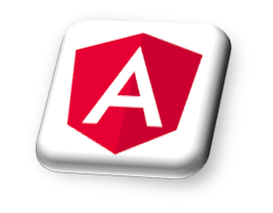Angular (also referred to as "Angular 2+") is TypeScript-based, free and open-source web application framework. Angular is a platform and framework for building single-page client applications using HTML and TypeScript. Angular is written in TypeScript. It implements core and optional functionality as a set of TypeScript libraries that you import into your applications.

Angular Material is a User Interface (UI) component library that developers can use in their Angular projects to speed up the development of elegant and consistent user interfaces. Angular Material offers you reusable and beautiful UI components like Cards, Inputs, Data Tables, Date pickers, and much more. Angular Material components help in constructing attractive, consistent, and functional web pages.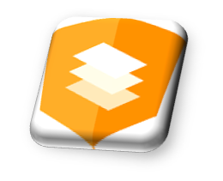

Tailwind CSS is an open-source CSS framework. The main feature of this library is that, unlike other CSS frameworks like Bootstrap, it does not provide a series of predefined classes for elements such as buttons or tables. Instead, it creates a list of "utility" CSS classes that can be used to style each element by mixing and matching. Tailwind CSS makes it quicker to write and maintain the code of your application

**Tools and Technology used**

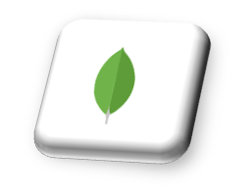MongoDB is a NoSQL database management application. NoSQL database systems offer an alternative to traditional relational databases using SQL (Structured Query Language). Data is stored in tables, rows, and columns in a relational database, with relationships between entities. MongoDB is designed to make data easy to access. The maximum BSON document size is 16 megabytes. MongoDB databases are schema less.

Django is a high-level Python web framework that enables rapid development of secure and maintainable websites. Built by experienced developers, Django takes care of much of the hassle of web development, so you can focus on writing your app without needing to reinvent the wheel. Django's primary goal is to ease the creation of complex, database-driven websites. The framework emphasizes reusability and "pluggability" of components, less code, low coupling, rapid development, and the principle of don't repeat yourself

**Working With Project: - Snapshot with explanation**

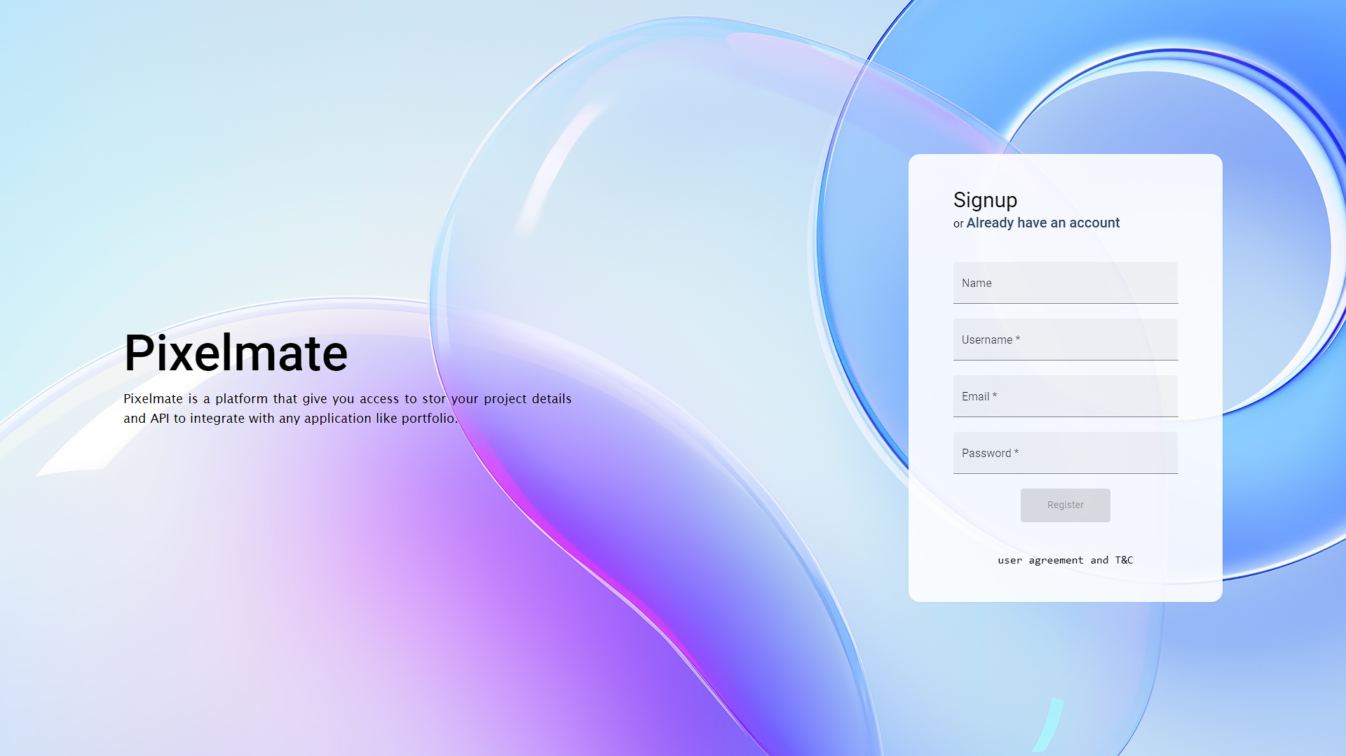

This is Signup page required details of user (like name, email, username and most important is password) and same as Signup page we have login page that is used to login to our app.

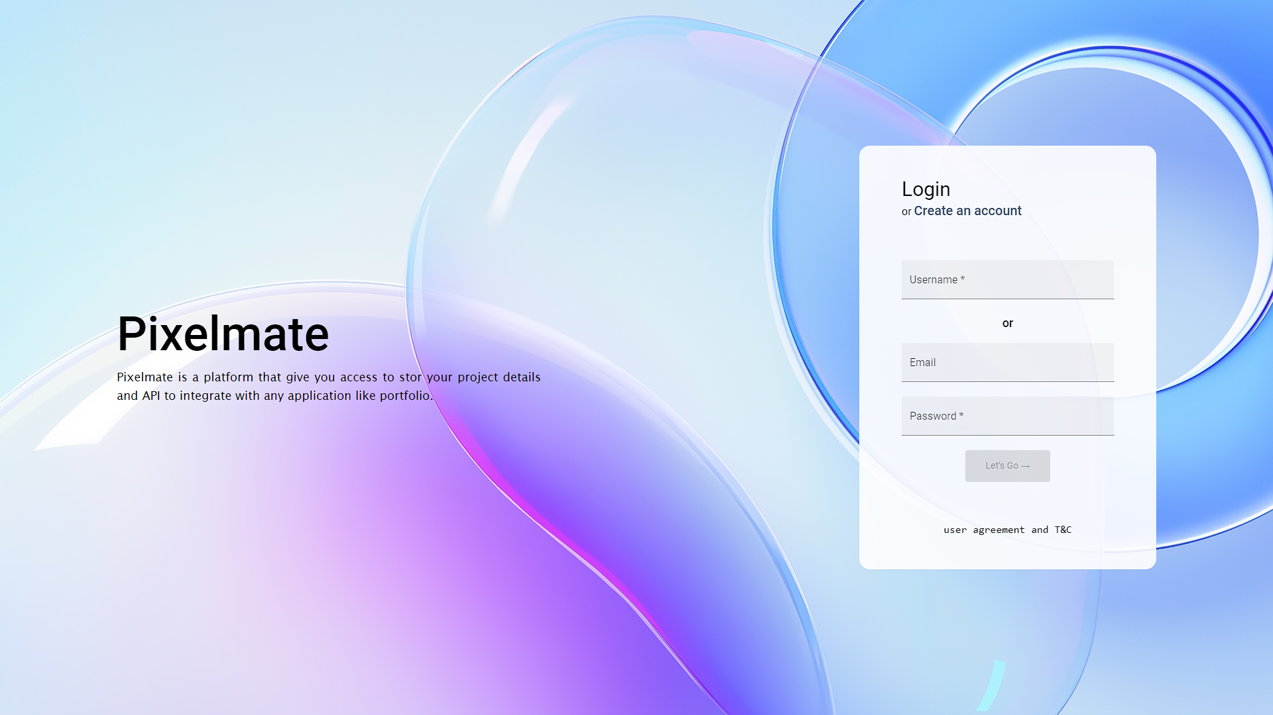

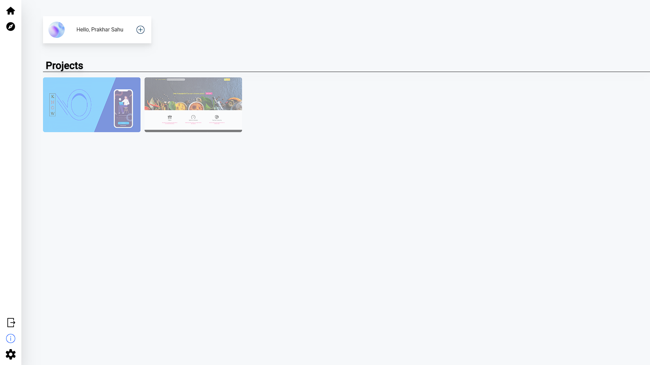

This is our home page look like a dashboard for our app. At First you have to create or start a new project where you have to fill details of your project (like title, description, technology used and a GitHub repository link). And below you can see you completed projects.

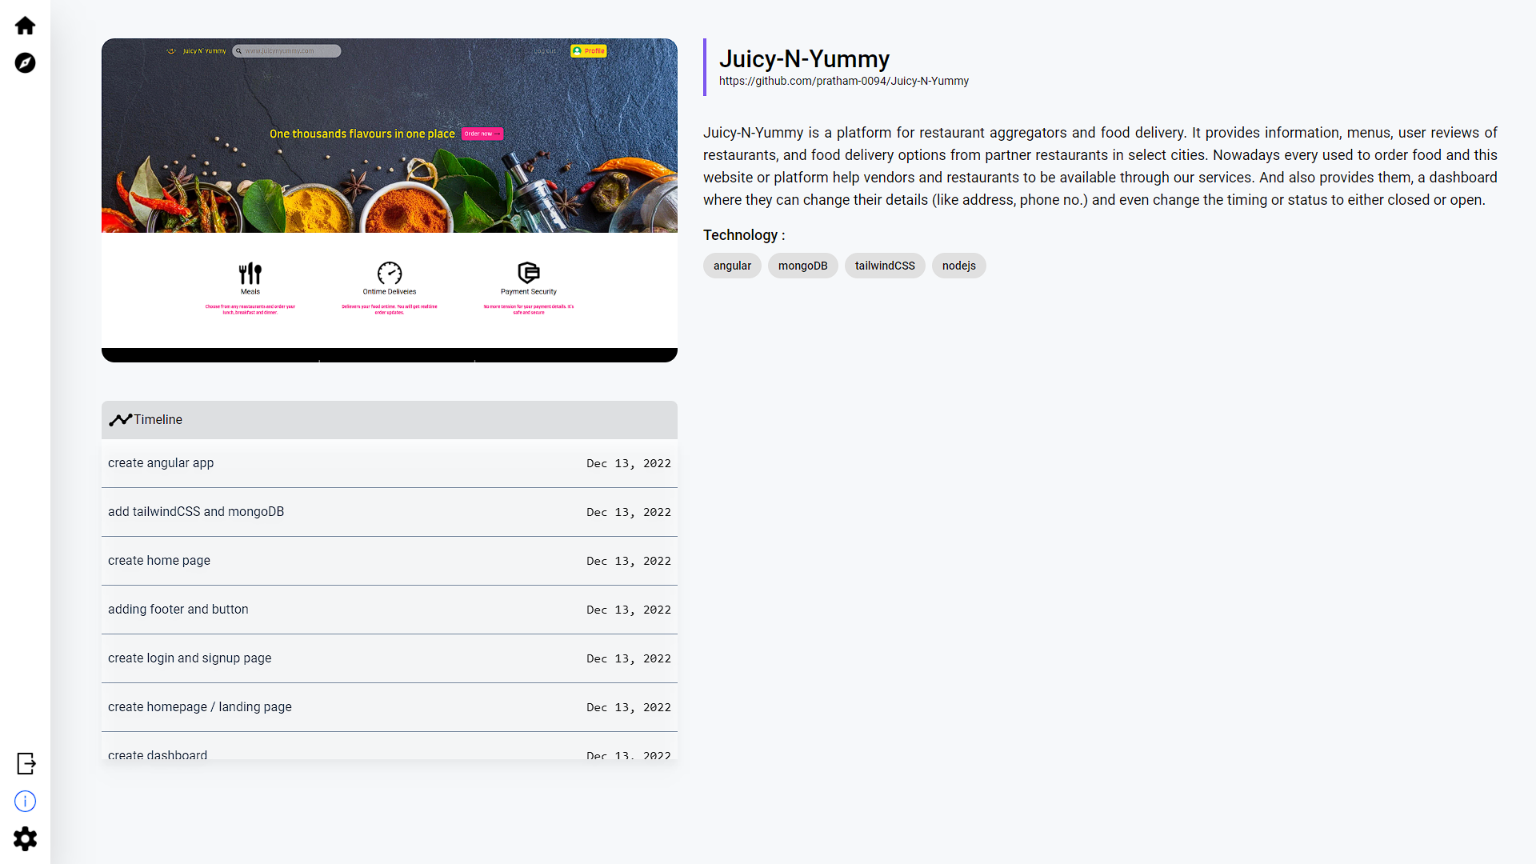

**CONCLUSION AND SCOPE FOR FUTURE WORK**

Nowadays, if you are a developer than it is must that you have to make some projects to show the level of experience and skills you have. And portfolio website is the best way you can talk about yourself i.e. skills, project, social media handles, industry experience or internships. So, more projects have more impact and helpful to build your resume.

As the portfolio is hosted so every time you make project you have to change the files and again host the portfolio. So, to solve this problem, we made this platform where you can store the data (project details) and show your projects in your portfolio website using the API’s (as the data will be store and retrieve from database) You don’t have to worry about changing the files from the hosted server.

**Future Works**

We can make this app more production and add more functionality to it like:

1) Add subtask option

2) Make challenge section more categorize

3) Add collaborator feature to group project